Electrical safety
- Look at the pictures below and answer the questions.
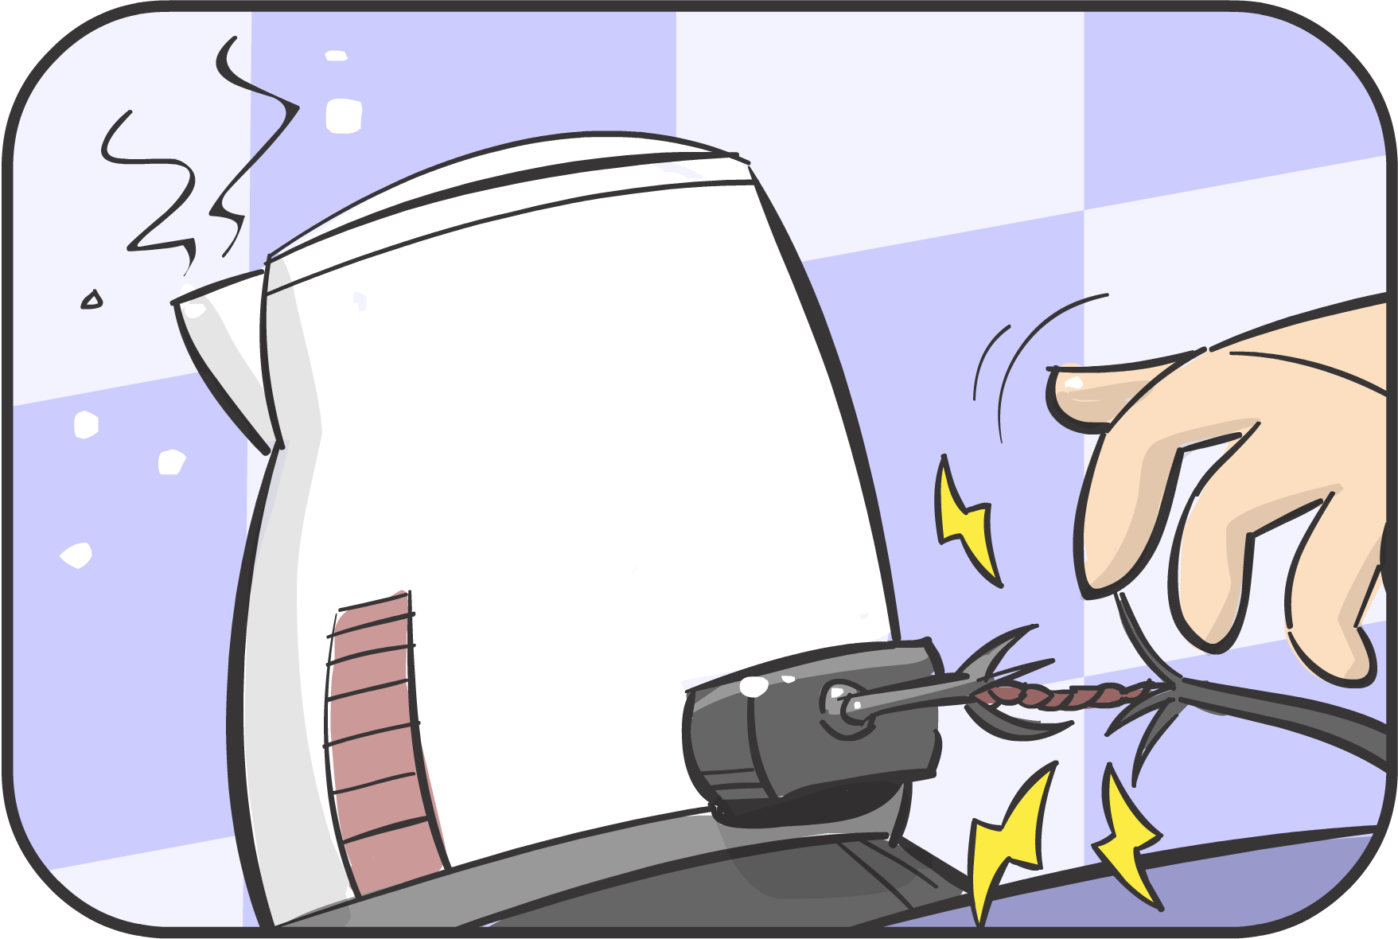 | How is this an electrical hazard?
What advice would you give about how to be safe in this situation?
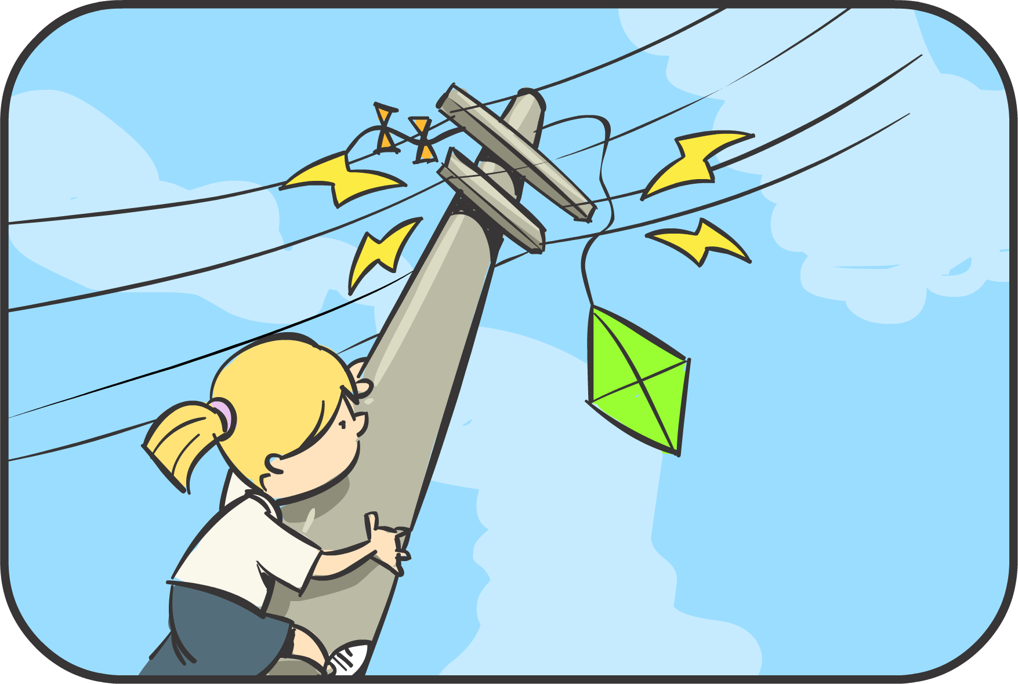 | How is this an electrical hazard?
What advice would you give about how to be safe in this situation?
- How will you ensure you are working safely with electrical circuits in the classroom?

